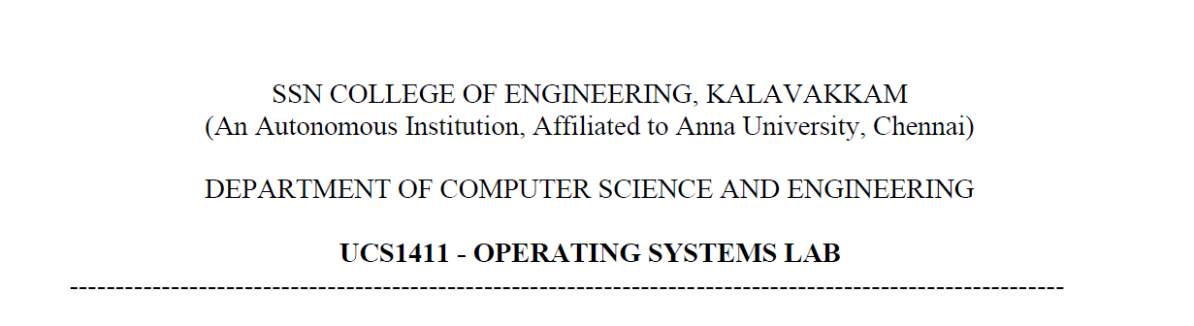

**UCS1412 – DBMS Lab**

**Assignment – 7**

Name: Jayannthan P T

Dept: CSE ‘A’

Roll No.: 205001049

**Title:** Triggers

**Spool File:**

*-- Write a PL/SQL Trigger for the following:*

*-- 1. The combination of Flavor and Food determines the product id. Hence, while*

*-- inserting a new instance into the Products relation, ensure that the same combination*

*-- of Flavor and Food is not already available.*

SQL>

SQL> SET SERVEROUTPUT ON;

SQL>

SQL> CREATE OR REPLACE TRIGGER BEFORE_PRODUCT_INSERT

  2  BEFORE INSERT ON PRODUCTS FOR EACH ROW

  3  DECLARE

  4      CT **NUMBER**:=0;

  5      CURSOR PROCURSOR IS SELECT * FROM PRODUCTS

  6      WHERE FOOD=:NEW.FOOD AND FLAVOR=:NEW.FLAVOR;

  7      RECORD PROCURSOR%ROWTYPE;

  8  BEGIN

  9      OPEN PROCURSOR;

 10      FETCH PROCURSOR INTO RECORD;

 11      IF PROCURSOR%NOTFOUND THEN

 12          CT:=1;

 13      END IF;

 14      CLOSE PROCURSOR;

 15      IF CT=0 THEN

 16          RAISE_APPLICATION_ERROR(-20000,'COMBINATION ALREADY AVAILABLE');

 17      END IF;

 18  END;

 19  /

Trigger created.

SQL>

SQL> INSERT INTO PRODUCTS

  2  VALUES ('20-BC','CHOCOLATE','CAKE',8.95);

1 row created.

SQL>

SQL> INSERT INTO PRODUCTS

  2  VALUES ('20-BC','CHOCOLATE','CAKE',8.95);

INSERT INTO PRODUCTS

            *

ERROR at **line** 1:

ORA-20000: COMBINATION ALREADY AVAILABLE

ORA-06512: at "1049.BEFORE_PRODUCT_INSERT", **line** 14

ORA-04088: error during execution of trigger '1049.BEFORE_PRODUCT_INSERT'

*-- 2. While entering an item into the item_list relation, update the amount in Receipts with*

*-- the total amount for that receipt number.*

SQL>

SQL> SAVEPOINT SAVE1;

Savepoint created.

SQL> ALTER TABLE RECEIPTS

  2  ADD AMT **NUMBER**;

Table altered.

SQL>

SQL> SELECT * FROM RECEIPTS

  2  WHERE RNO=51991;

       RNO RDATE            CID        AMT

*---------- --------- ---------- ----------*

     51991 17-OCT-07         14

SQL>

SQL> CREATE OR REPLACE TRIGGER ITEM_LIST_ITEMS_AMOUNT

  2  BEFORE INSERT ON ITEM_LIST FOR EACH ROW

  3  BEGIN

  4      UPDATE RECEIPTS

  5      SET AMT=(SELECT SUM(PRICE) FROM ITEM_LIST,PRODUCTS

  6      WHERE RNO=:NEW.RNO AND PID=ITEM) WHERE RNO=:NEW.RNO;

  7      UPDATE RECEIPTS

  8      SET AMT=AMT+(SELECT PRICE FROM PRODUCTS

  9      WHERE PID=:NEW.ITEM) WHERE RNO=:NEW.RNO;

 10  END;

 11  /

Trigger created.

SQL>

SQL> INSERT INTO ITEM_LIST VALUES(51991,5,'45-VA');

1 row created.

SQL> SELECT * FROM RECEIPTS

  2  WHERE RNO=51991;

       RNO RDATE            CID        AMT

*---------- --------- ---------- ----------*

     51991 17-OCT-07         14      31.45

*-- 3. Implement the following constraints for Item_list relation:*

*-- a. A receipt can contain a maximum of five items only.*

*-- b. A receipt should not allow an item to be purchased more than thrice.*

SQL>

SQL> SAVEPOINT SAVE1;

Savepoint created.

SQL>

SQL> CREATE OR REPLACE TRIGGER MAX_CONST_ITEMS

  2  BEFORE INSERT ON ITEM_LIST FOR EACH ROW

  3  DECLARE

  4      CURSOR RNOCOUNT IS SELECT COUNT(*) AS COUNT1 FROM ITEM_LIST

  5      WHERE RNO=:NEW.RNO;

  6      CURSOR RNO_ITEM_COUNT IS SELECT COUNT(*) AS COUNT2 FROM ITEM_LIST

  7      WHERE RNO=:NEW.RNO AND ITEM=:NEW.ITEM;

  8      RNO_ROW RNOCOUNT%ROWTYPE;

  9      RNO_ITEM_ROW RNO_ITEM_COUNT%ROWTYPE;

 10  BEGIN

 11      OPEN RNOCOUNT;

 12      OPEN RNO_ITEM_COUNT;

 13      FETCH RNOCOUNT INTO RNO_ROW;

 14      FETCH RNO_ITEM_COUNT INTO RNO_ITEM_ROW;

 15      IF RNO_ROW.COUNT1>=5 AND RNO_ITEM_ROW.COUNT2>=3 THEN

 16          RAISE_APPLICATION_ERROR(-20001,'THE RECEIPT ALREADY HAS 5 ITEMS AND THE ITEM IS PURCHASED THRICE');

 17      ELSIF RNO_ROW.COUNT1>=5 THEN

 18          RAISE_APPLICATION_ERROR(-20002,'THE RECEIPT ALREADY HAS 5 ITEMS');

 19      ELSIF RNO_ITEM_ROW.COUNT2>=3 THEN

 20          RAISE_APPLICATION_ERROR(-20003,'THE ITEM IS PURCHASED THRICE');

 21      END IF;

 22      CLOSE RNO_ITEM_COUNT;

 23      CLOSE RNOCOUNT;

 24  END;

 25  /

Trigger created.

SQL>

SQL> INSERT INTO ITEM_LIST VALUES(52761,6,'90-ALM-I');

INSERT INTO ITEM_LIST VALUES(52761,6,'90-ALM-I')

         *

ERROR at **line** 1:

ORA-20002: THE RECEIPT ALREADY HAS 5 ITEMS

ORA-06512: at "1049.MAX_CONST_ITEMS", **line** 16

ORA-04088: error during execution of trigger '1049.MAX_CONST_ITEMS'

SQL> INSERT INTO ITEM_LIST VALUES(83085,6,'45-CH');

INSERT INTO ITEM_LIST VALUES(83085,6,'45-CH')

         *

ERROR at **line** 1:

ORA-20002: THE RECEIPT ALREADY HAS 5 ITEMS

ORA-06512: at "1049.MAX_CONST_ITEMS", **line** 16

ORA-04088: error during execution of trigger '1049.MAX_CONST_ITEMS'

SQL> INSERT INTO ITEM_LIST VALUES(32565,4,'50-APP');

1 row created.

SQL> INSERT INTO ITEM_LIST VALUES(32565,4,'50-APP');

INSERT INTO ITEM_LIST VALUES(32565,4,'50-APP')

            *

ERROR at **line** 1:

ORA-20003: THE ITEM IS PURCHASED THRICE

ORA-06512: at "1049.MAX_CONST_ITEMS", **line** 18

ORA-04088: error during execution of trigger '1049.MAX_CONST_ITEMS'

SQL> rollback;

Rollback complete.